

**Applied Physics for**

**Scientists and**

**Engineers**

**To ﬁnd the Ratio of Principle Speciﬁc heat ( Cp/Cv) of  Air by Element Desorme’s Method:**

**Submitted to**

Sir Haseen Ullah Jan

**Submitted by**

Muhammad Sadeeq

Computer system engineering

Sec C Roll No , 75025



**Introduction:**

The well-known Clement-Desormes method for heat capacity ratio employs a large bottle  of air, an oil manometer, and a rubber pressurizing bulb. The air sample at slightly elevated  pressure undergoes a rapid adiabatic expansion followed by isochoric warming back to  room temperature.

The usual calculation of the ratio is sidestepped in favor of a new interpretation which  recognizes that for air, the work done in the rapid expansion must equal the heat absorbed  when the gas returns to room temperature.

These quantities and the accurately known differences between the PVT states permit a  direct determination of the heat capacity Cv.

Students are exposed to the concept of irreversible work, path independence of DeltaE,  and experimentally use the equation Delta E = Q + W. Since air is diatomic and closely  obeys the ideal gas law, the heat capacities and various partial differential coefﬁcients can  be calculated and compared with experimental results.



**Apparatus:**

Following apparatus is used for determining speciﬁc heat of air:

1. Manometer
2. Tubes
3. Kerosine Oil
4. Stand
5. Rubber Tubes
6. Wooden Box
7. Meter Rod
8. Flask
9. Packing material

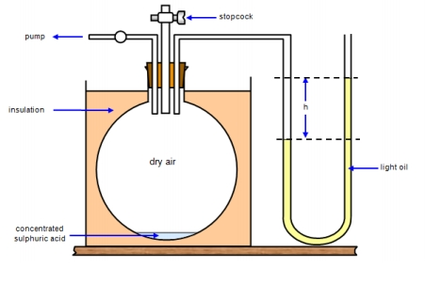

=r=

**Procedure:**

Following procedure is followed:

1. Surface level of Kerosene oil is noted in both limbs of manometer.
2. These points are considered as zero points when level in both levels are the same.  3. Open one valve when other is closed, start pumping air into ﬂask, due to pressure

and temperature will increase in the ﬂask.

1. Level of the kerosene oil will increase in the limb. While other limb lowers down.  Stop pumping then and close the valve.
2. Level will start lowering because of balancing of pressure and temperature.
3. Note the ﬁnal positions of the level of kerosene in the limbs. A will be high and B  will be low.
4. Repeat this process for expanding air.
5. Note the readings again.Find H2 and calculate ratio as,

*Cp H* 1 *Cv H* 1−*H* 2

9. For diatomic gases r value is 1.4.

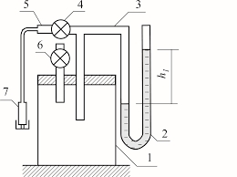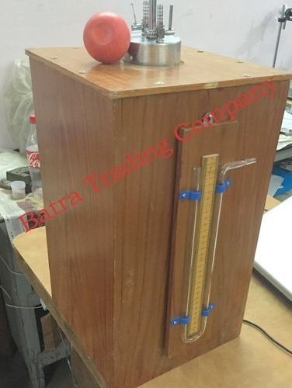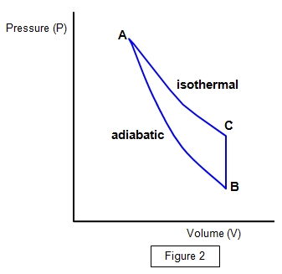

**Readings:**

|  |  |  |  |  |  |  |  |
| --- | --- | --- | --- | --- | --- | --- | --- |
| S.No. | A in cm | B in cm | H1=A-B | A in cm | B in cm | H2=A+B | *Cp* =r=  *H* 1   *H* 1−*H* 2 |
| 1 | 15 |  |  |  |  |  |  |
| 2 |  |  |  |  |  |  |  |
| 3 |  |  |  |  |  |  |  |
| 4 |  |  |  |  |  |  |  |
| 5 | 11.2 |  |  |  |  |  |  |
| 6 | 15 |  |  |  |  |  |  |
| 7 | 16 |  |  |  |  |  |  |